MOBILE COMMUNICATION STANDARDS AND PROTOCOLS

* **PAVAN KUMAR MALLADI**

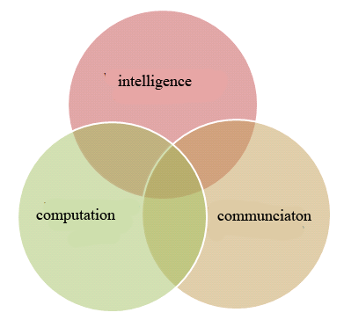

**Introduction:**

Ubiquitous computing also known as pervasive computing is a model of human-computer interaction in which information processing is thoroughly integrated into everyday objects and activities.

According to Mark Weiser vision of ubiquitous computing computers are those that disappear from our Conscience thought. Now a day’s Ubiquitous computing has became so prevalent that we have stopped noticing that it uses some technology. The way billboards appear, traffic signals change, the scanning of items on cash desk, mobile phones, GPS etc all use technologies which we take for granted.

There has been a significant change in the hardware technology in the recent times. Wireless Networking is developed, processing capabilities were increased to greater bounds, and storage capacities are also enhanced. Therefore mobile phones, PDA are found as suitable replacement for the traditional computing which makes use of the hardware effectively. But this adoption requires common standards across many products and locales.

**Concept of three circles:**

Any knowledge advantage machine that supports ubiquitous computing must possess high intelligence, faster computation capabilities and efficient connectivity. This can be depicted using three circles. A machine with these characteristics knows well about the user and acts according to his wish. It can compute and analyze the given data at the faster rate and communicate it to the user in the required time. A mobile phone is also a knowledge advantage machine which is built on this concept.

Fig 1. Three circles

**Moblie Communications**:

*Principles:*

Mobile phones can be used to communicate over longer distances without any physical connection such as wires. Each mobile uses a separate radio channel to talk to cellular tower. This tower communicates to many mobiles at once using one channel per mobile. Every channel uses a pair of frequencies for communication- one for forward link and other for reverse link. Radio energy dissipates over the distance, so the mobiles must stay near the base station to maintain communication. Fig 2 shows the structure of basic mobile telephone service network.

*Cellular architecture:*

In cellular broadcasting many transmitters are placed throughout a coverage area, each transmitter serving the mobile phones present in that area. The cell is the basic geographical unit of cellular system. Mobiles that communicate with the same frequency in a cell would cause interference problems. It was found that reducing the radius by few hundred meters is the potential solution to the interference problem thus serving increased number of calls in a geographical area.

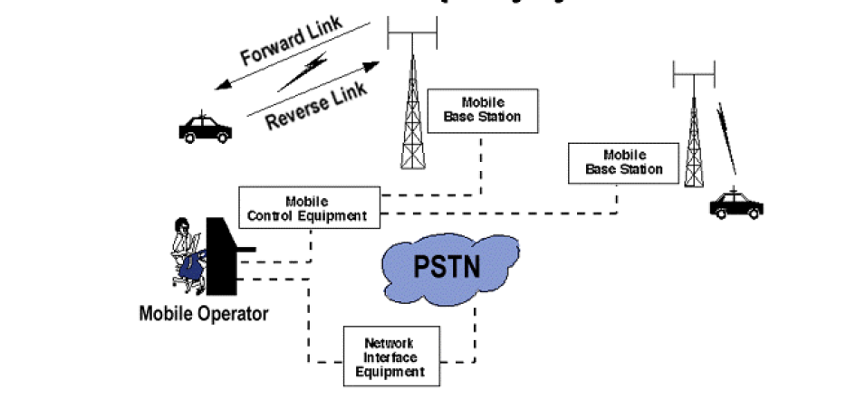

Fig 2. Mobile Communications

The cellular concept employed allows cells to be sized according to the subscriber density and demand of a given area. Cells can be added to accommodate the growing population and the frequency can be reused among different cells. Conversations can be handed off from cell to cell to maintain constant phone service as the user moves from one cell to other.

Fig 3. clusters

The amount of frequency spectrum available for the mobile users is limited, for the efficient use of this spectrum each area is divided into hexagonal cells 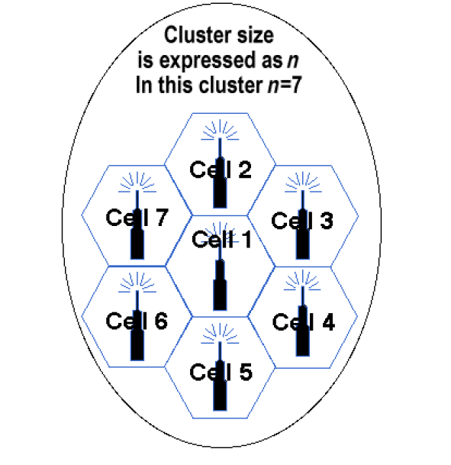according to specific guidelines such as the density of mobile users, landscape etc. A cluster is a group of cells. No frequency is reused with in a cluster. The above Fig shows a seven cell cluster. Cells are assigned a group of channels that are completely different from neighboring cells, thus the frequency can be reused among the cells which are far enough from each other.

As a service area becomes full of users cell splitting is done, the area is divided into still smaller cells. As a result urban centers can be split into smaller areas to support the heavy traffic, while larger cells can be used in remote rural areas.

*Handoff*

To avoid interference adjacent channels do not use the same frequencies, so a call must transferred from on cell to the other when the mobile moves from once station to other base station. To accomplish this, the concept of hand off is introduced. When two parties are on call and when a mobile unit moves out of the coverage area of a given cell site, the reception becomes weak and the base station requests the handoff then the mobile switches to a stronger frequency base station without interrupting the call.

Fig 4. Handoff between two cells

The above Fig shows how the mobile switching is done between two cells. The home location register (HLR) is a central database that contains details of each mobile phone subscriber that is authorized to use the GSM core network. The Temporary Mobile Subscriber Identity (TMSI) is the identity that is most commonly sent between the mobile and the network. TMSI is randomly assigned by the Visitor Location Register (VLR).It is the database which stores information about all the mobiles that are currently under the jurisdiction of the Mobile Telephone Switching Center(MTSC), which it serves. A group of base stations is named as location area or routing area. The location update procedure allows a mobile device to inform the cellular network, whenever it moves from one location to the other. The mobiles are responsible for detecting location area codes. When a mobile finds that the location area code is different from its last update, it performs another update by sending to the network a location update request together with its previous location and it’s TMSI.

**MOBILE STANDARDS:**

***1st Generation:***

1G (First Generation) is the name given to the first generation of mobile telephone networks. These mobiles used analogue circuit switched technology with FDMA and worked mainly in the 800-900 MHz frequency bands. The network had a low traffic capacity, unreliable handover, poor voice quality , poor security. FDMA gives users an individual allocation of one or several frequency bands.

These mobiles appeared in the early 1980’s.Then each country developed its own system for the 1G mobiles. In 1982 a group called GSM (Groupe Special Mobile) was formed with mission to develop a mobile system that was compatible worldwide.

First Generation mobile phone networks were the earliest cellular systems developed that rely on a network of distributed transceivers to communicate. These transceivers typically allocated with a 25 MHz frequency band for the signals to be sent from the cell base station to handset and another 25 MHz band for the reverse signals. These bands were then split into number of communication channels each of which is used by a particular caller.

***2nd Generation:***

These are the next generation mobiles after the

1G mobiles. While 1G is analog 2G is completely digital. The demand for 2G is particularly more in densely populated areas where increasingly sophisticated methods had to be employed to handle large number of calls and also to avoid the risk of interference and dropped calls. In addition to the services provided by 1G these mobiles provide facilities such as caller identity and text messaging. These digital mobiles emit less power from the phones as results it has lesser health risks. Most of the 2G mobiles are based on Time division multiple access (TDMA).It is a channel access method for shared medium networks. It allows several users to share the same frequency channel by dividing the signal into different time slots

Next to 2G also the terms 2.5G and 2.75G have been come up, but these terms are not officially defined. These mobiles enable data transfer using packet switched domains which is normally used in 3G services. GPRS and EDGE are the two technologies that were prominent in 2.5G mobiles.

*GPRS:*

General Packet Radio Service is a data service provides data rates of 56-114 kbps. As GPRS is packet switched service, the data transfer is charged per kilobyte, contrary to the circuit switched services which is charged per second. So a user can be online for a long time and will only be charged for the transmitted data.

It’s services include “Always on“internet access, Instant Multimedia Messaging (MMS), Internet applications for smart devices through wireless application protocol (WAP) etc.

*EDGE:*

Enhanced Data Global Evolution is a backward compatible digital mobile phone technology that allows improved data transmission rates and enhanced reliability. It provides up to three times the data capacity of GPRS, about 384 kbps. This technology has made mobile internet possible. Downloading video, music clips and e-mail on the move are possible with these standard mobile phones. This also called as EGPRS, because it is the enhanced version of GPRS.

EDGE helped in filling the gap between GPRS and 3G. EDGE helps operators adopt a more flexible approach of customer segmentation based on price and performance. A mobile switches to EDGE automatically when both phone and network support it and will automatically revert to the slower GPRS standard when EDGE service is not available.

***3rd Generation:***

This generation phones were implemented in the year 2002. Japan was the first country to adopt the 3G technology. Its idea is to include wide-area wireless voice telephone, video calls and data etc. in a mobile. In this, data is transmitted through radio signals and uses multiplexing techniques such as CDMA and TDMA to maximize throughput. UMTS and HSPDA are enhanced 3G mobile telephony communications protocols.

*UMTS:*

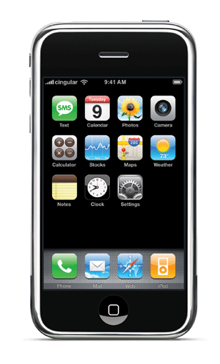Universal Mobile Telecommunications is 3G technology being developed to 4G technology. UMTS enables Internet, e-mail, e-commerce , music, video clips and video conferencing etc.

Fig 5. Generation iphone

These standard mobiles supports maximum data speeds of 2 mbps/sec. Due to the higher speed rates this has a quality comparable to normal Internet.

Unlike EDGE and GPRS, UMTS requires new cell towers and new frequency allocations. However, it is closely related to GSM/EDGE as it borrows and builds upon concepts from GSM. UMTS phones are highly portable they have been designed to roam on to other UMTS networks. UMTS and GSM are dual mode devices. If mobile travels out of UMTS coverage area it can handoff to available GSM base station.

3G has standardized four classes for the data traffic.

1. Conversational class:

Voice, video traffic, video gaming

1. Streaming class:

Multimedia, video conferencing

1. Interactive class:

Web browsing, database, networking

1. Background class:

Email, SMS

3G standard phones support all the four classes of data traffic. Recently apple has introduced 3Gs iphone which has faster data support than 3G iphone

*HSPDA:*

High-Speed Downlink Packet Access (HSDPA) is an enhanced 3G mobile telephony communication protocol in the High Speed Packet Access(HSPA) family, also coined 3.5G, to have higher data transfer speeds and capacity. Current HSDPA deployments support down-link speeds up to 1.8 to14.0 Mbit/s. These increased data rates made it possible for providers to launch media rich applications and services. The users can download high resolution images and high graphics oriented multi player games.

4G:

It is the next generation mobile standard. Though there is no formal definition of 4G, this advanced mobile technology provides voice, data, video at any place and any time seamlessly. 4G can be termed as MAGIC: “Mobile multimedia, Any time anywhere, Global mobility support, Integrated wireless solution and Customized personal services. It will have to provide higher data rates, broader bandwidths and on the top must integrate to the existing mobile technologies. Some of the 4G technologies are UMTS (8.0), HSOPA, WIMAX.

**WI-MAX:**

Wi MAX (World Wide Interoperability for MicroWave Access), a radio technology is a new standard, based on IEEE 802.16.It has recently been approved as an IMT 2000 technology by ITU. This decision creates opportunity for global implementation to deliver mobile Internet. With Wi-MAX it is possible to enjoy uninterrupted communication in a moving car or train even in the remote places.

This Wi-MAX has given birth to the concept of Global Area Network(GAN).The proposal for GAN is IEEE 803.30.A true GAN would work like today’s mobile phone network with users able to travel across the country and still have access to the network the whole time.

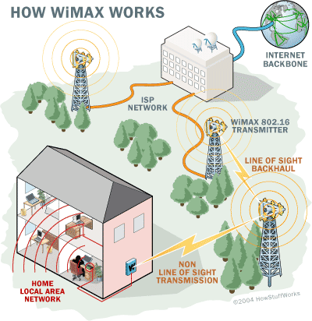

Wi MAX network is capable of providing broad band speeds to a coverage of over 30 miles radius with single base station but that is possible only in ideal condition. Practically a single base station provides broadband services with in a range of 4-5 miles(Non Line of sight and real time traffic conditions).A fastest Wi-MAX can handle speeds upto 70 mega bits per second.

A WiMAX system consists of two parts

WiMAX tower

WiMAX receiver

Wi-MAX tower is similar to a cell phone tower and can provide coverage to a very large area of around 3000 sq miles.Wi-MAX receiver and antenna could be a small box that could be built into a laptop to access the service.

*How it works:*

A Wi-MAX tower may connect to internet backbone or it may connect to another Wi-MAX tower using a line of sight. This connection to the second tower (back haul) along with its ability to cover large area allows Wi-MAX to provide coverage to remote areas also.

Wi-MAX in fact can provide two forms of wireless services.

*a) Non line of sight:* It is Wi-Fi sort of service where a small antenna on a computer connects to the tower nearby. In this mode Wi-MAX

uses lower frequency range from 2 GHz to 11 GHz. The lower wave length transmissions are not easily disrupted by physical obstruction. They are able to diffract, bend around obstacles.

b) *Line of Sigh*t: Here a fixed dish antenna points straight at the Wi-MAX tower from a rooftop or a pole. This connection is stronger and more stable, so it can able to send a lot of data with fewer errors. This transmission uses higher frequencies, with range reaching up to 66 GHz. At higher frequencies there is less interference and lost more bandwidth.

*Future:*

WiMax is referred to as dominant technology in the coming years. By next year its market worth may rose to $5 billion. The biggest market for Wi-MAX is in China, where IEEE and the Chinese government are already in discussion to make Wi-MAX the nation standard.

**CDMA VS GSM:**

In cellular services CDMA and GSM are two main competing technologies.

Code Division Multiplexing refers to several protocols used in 2G, 3G and 4G cellular communications. It allows numerous signals to occupy a single transmission channel optimizing the use of available bandwidth. CDMA uses analog to digital conversion in combination with spread spectrum technology. The frequency of the transmitted signal made to vary according to a defined pattern, so it can be intercepted only by a receiver whose frequency response is programmed with the same code. There are trillions of possible frequency-sequencing codes; this makes cloning difficult and enhances security and privacy.

GSM phones uses SIM(subscriber identity module) cards. The removable SIM card allows phones to be instantly activated, interchanged, swapped out and upgraded, all without carrier intervention. The SIM itself is tied to the network, rather than the actual phone. Phones that are card-enabled can be used with any GSM carrier. If you need to make calls to other countries, a GSM carrier can offer international roaming, as GSM networks dominate the world market. There are about 1 billion GSM users around the world. 82% of the global market is dominated by GSM mobiles.

**RSS FEEDS: **

Tracking information form number of web pages is becoming increasingly difficult task. Visiting favorite webpage’s everyday is not possible. RSS Feeds provides an easy solution for this.

Really Simple Syndication (RSS) lets online users freely subscribe to their choice of content across the web. Aggregation tools display summaries of these subscriptions, which update automatically when new information is available.

.

RSS Feeds is an XML based format for easily distributing and aggregating web content. The users determine their favorite websites and properly configured RSS aggregator will syndicate selected list of hyperlinks and headlines and displays the content on the user’s desktop regularly. This content keep on updating dynamically without the user interaction. The following figure shows how the RSS Feed works.

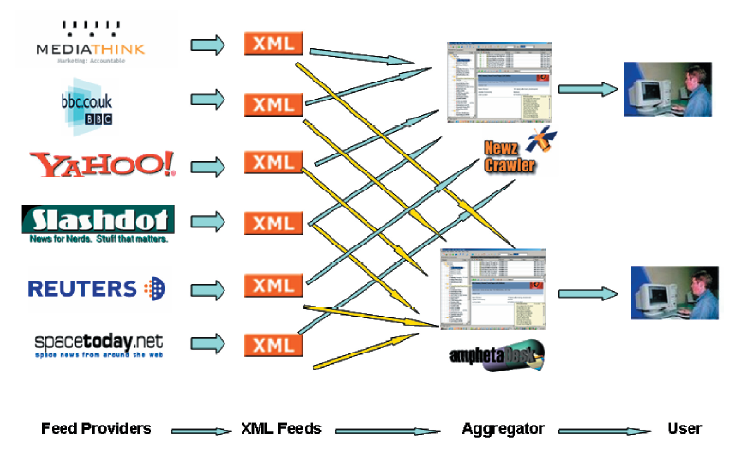

Fig 7. RSS feeds

RSS is still in its infancy stage of adoption but the velocity and mass of its adoption confirms that it would become one of the most important development in the distribution of media in coming years.

*Benefits:*

The key benefits of RSS include

1. Fast updating and auto-retrieving summaries of the latest content
2. Content comes to the user with minimum effort from the user.
3. Less time spend on surfing.
4. Avoids extraneous information which includes ads and survey forms etc.
5. No need to provide any personal information to the website, thus private information remains secured.
6. For content providers it acts as a means to build the brand awareness and the site/user relationship.

*Impact on Email*:

RSS is believed to be technology poised to challenge email’s monopolistic role. In emails users have significantly reduced reading their

commercial emails and moreover implement spam blockers which often block legitimate emails. On the other hand RSS are 100 percent opt in approach. A user must pro-actively choose to receive a feed. By any means one cannot send unsolicited content via RSS. RSS has no issues with blacklists, spam complaints etc.

*Future:*

RSS is simple standard for moving content across web. The next step in the evolution is a standardized way to syndicate rich media and broadband content. Currently users download music and movies, a rich media RSS standard(RM RSS) should allow publishers to make such content available as news articles.

RM RSS would allow users to create their own personal broadband channels. It is believed that if RSS gets integrated with programs like Bit Torrent, we would no longer be sitting in front of our TV at inconvenient time to watch our favorite show, instead RSS aggregators will update us on new files created to open the file or the link at our convenience on our computer without even having a TV set.

**Conclusion:**

The innovation of mobile communication standards has been very active area over the past 10 years. We can observe that at each generation the characteristics of three circles are suitably implemented making the mobiles most suitable for the ubiquitous computing. There has been increase in the connectivity from 1 Generation mobiles to 3 rd generation mobiles thus showing how connectivity is achieved. There is also increase in the processors speeds that are used in the different generations of the mobiles phones. As result lot of applications such as multimedia games, MMS, live TV are possible in the latest standard mobiles. We can also interpret that the intelligence of the latest standard mobiles are greatly increased. The mobile can dynamically switch to the standard the mobile and network supports automatically without the user intervention and moreover the mobile can switch between WI-FI and wireless service provided by the provider automatically. There are lot applications that were developed for the 3G mobile phones that have high intelligence and make our life comfortable.

The speeds of the latest standard mobiles phones reached to 14 mbps thus the bandwidth is not at all an issue anymore. The entire bandwidth is not used in 3G mobiles. The bandwidth will increase much more in the 4G standards, so much of the research must be focused in best using the entire bandwidth of the mobiles. Implementing of 4G would become much helpful as the entire area, even the remote possible areas can be connected, thus making it easier to carry any operation.

References:

* [www.wikipedia.org](http://www.wikipedia.org)
* [www.iec.org](http://www.iec.org/)
* <http://www.howstuffworks.com/wimax1.htm>
* A white paper on ‘Innovations of mobile communication standards and their applications for telecom companies’.
* A paper on ‘Disappearing Hardware’ by Mark Weiser’
* [www.wimax.com](http://www.wimax.com/)
* [www.slideshare.com](http://www.slideshare.com/)